1. Descendants of the Sun Song Joon Ki Song Hye Kyo Fox Rabbit Plush Doll

Sold Out ₱1,247.50

Top of Form

Style

Foxhttps://cdn.shopify.com/s/files/1/0998/7652/t/8/assets/soldout.png?18233928706288682492

Rabbithttps://cdn.shopify.com/s/files/1/0998/7652/t/8/assets/soldout.png?18233928706288682492

Set (Fox & Rabbit)https://cdn.shopify.com/s/files/1/0998/7652/t/8/assets/soldout.png?18233928706288682492

Bottom of Form

Product Details

Get your very own Descendants of the Sun dolls. We carry both military fox and military rabbit versions. Descendants of the Sun is a hit 2016 military romance drama featuring Song Joong Ki and Song Hye Ko. The series was a major hit in South Korea and received immense popularity across Asia.

See our Descendants of the Sun fox plushie featured in both Steph from HallyuBack and Cloudy from CuriousCloudy's videos below!

1. [**Home**](https://starberrykoko.com/)**»**[**Bags**](https://starberrykoko.com/collections/bags)**» Korean TV Drama Doctor Crush (Doctors) Park Shin Hye Bag**

* 2. Korean Kpop Band SNSD Girls Generation Yoona Lion Heart MV Ribbon Blouse
* $ 19.95 USD 997.50 php
* Top of Form
* Quantity
* Bottom of Form

Product Details

* Add some k-pop flair to your wardrobe with this Girls Generation inspired blouse worn by Yoona in SNSD's hit Lion Heart MV. The delicate blouse features a charming peter pan collar and comes with a black ribbon.

|  |  |
| --- | --- |
| Size | Medium |
| Material | Cotton |

1. Korean TV Drama Love Rain Yoona Canvas Backpack

Top of Form

Bottom of Form

Product Details 2,497.50 php

View More

* Product Type [Accessories, Drama, Bags](https://starberrykoko.com/collections/types?q=Accessories%2C%20Drama%2C%20Bags)
* Collection: [Bags](https://starberrykoko.com/collections/bags)

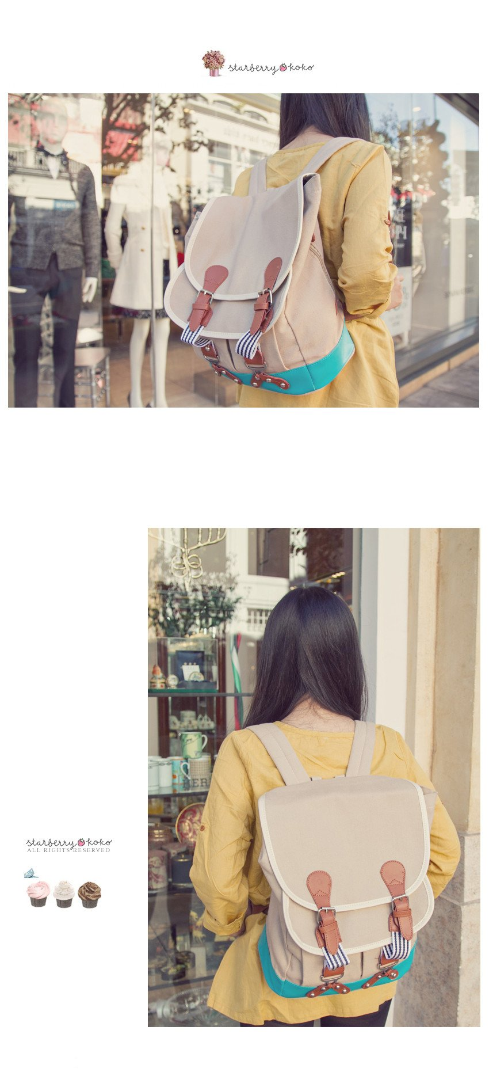

# 4. The Heirs Park Shin Hye Backpack

$ 49.95 USD 2,497.50 php

Top of Form

Quantity

Bottom of Form

Product Details

View More

* Product Type [Accessories, Drama, Bags](https://starberrykoko.com/collections/types?q=Accessories%2C%20Drama%2C%20Bags)
* Collection: [Bags](https://starberrykoko.com/collections/bags)

# 5. Big Bang Alive Tour Red White Varsity Letterman Jacket

$ 49.95 2,497.50 php

Top of Form

Size

Medium

Large

Quantity

Bottom of Form

Product Details

Show your love for Korean Kpop Bang, Big Bang, and band members G-Dragon,TOP, Taeyang, Daesung and Seungri with this varisty letterman jacket as seen worn during their 2012 Alive Tour concert. Our fan-made jackets are made of cotton and PU leather, featuring removable patches and intricate detailing.

|  |  |
| --- | --- |
| **Size** | **Medium** |
| Shoulders | 16" |
| Bust | 32-35" |
| Sleeves | 22" |
| Length | 25.5" |
| **Size** | **Large** |
| Shoulders | 18" |
| Bust | 35-40" |
| Sleeves | 24" |
| Length | 26" |

# 6. Girls' Generation SNSD in New York OnStyle Tiffany Dress

$ 44.95 USD 2,247.50 php

Top of Form

##### Quantity

Bottom of Form

#### Product Details

|  |  |
| --- | --- |
| Size | US Medium |
| Shoulders | 15" |
| Bust | 32-35" |
| Length | 34" |
| Sleeves | 10" |

#### View More

* Product Type [Dresses, Music](https://starberrykoko.com/collections/types?q=Dresses%2C%20Music)

# 7.

# Descendants of the Sun Song Joong Ki Yoo Si Jin Cartoon Character Short Sleeves T-Shirt Top

Sold Out ₱1,199.50

Top of Form

Bottom of Form

Product Details

Descendants of the Sun is a hit 2016 South Korean TV drama starring Song Joong Ki and Song Hye Kyo in a military romance setting. The series was a huge hit in Korea and achieved immense popularity across Asia.

|  |  |
| --- | --- |
| Size | Medium (Unisex) |
| Shoulders | 17.5" |
| Length | 25.5" |
| Bust | 32-34" |
| Sleeves | 7" |

Check out Steph from HallyuBack wearing our Descendants of the Sun Song Joong Ki / Yoo Si Jin cartoon character t-shirt in her video below!

# 8. Boyfriend Cellphone Dust Plug Jack Charm

$ 7.00 USD ₱350.00

Top of Form

Quantity

Bottom of Form

Product Details

Show your love for Korean Kpop Band Boyfriend (보이프렌드) and members Donghyun, Hyunseong, Jeongmin, Youngmin, Kwangmin and Minwoo with this cute Boyfriend dust plug for your cellphone.

|  |  |
| --- | --- |
| Charm | 1" x 2" |

# 9. 2NE1 Zipper Hoodie

$ 64.95 ₱3,247.50

Top of Form

Color

Red

Yellow

Size

Small

Medium

Large

Quantity

Bottom of Form

Product Details

|  |  |
| --- | --- |
| **Size** | **Small** |
| Shoulders | 16" |
| Length | 24" |
| Sleeves | 22" |
| **Size** | **Medium** |
| Shoulders | 17" |
| Length | 25" |
| Sleeves | 22.5" |
| **Size** | **Large** |
| Shoulders | 19" |
| Length | 26" |
| Sleeves | 22.5" |

# 10. EXO Luhan Penguin Pullover Sweater

$ 48.95 USD ₱2,447.50

Top of Form

Quantity

Bottom of Form

Product Details

|  |  |
| --- | --- |
| Shoulders | 16" |
| Bust | 32-36" |
| Length | 23" |
| Sleeves | 23" |
| Material | Cotton |
| Thickness | Fleece |

View More

# 11. EXO Kris SUP Navy Pullover Sweater Top

$ 44.95 US ₱2,247.50

Top of Form

##### Quantity

Bottom of Form

#### Product Details

|  |  |
| --- | --- |
| Shoulders | 18" |
| Bust | 32-36" |
| Length | 24" |
| Sleeves | 26" |
| Material | Cotton |

#### View More

* Product Type [Tops, Music](https://starberrykoko.com/collections/types?q=Tops%2C%20Music)
* Collection: [Music](https://starberrykoko.com/collections/music)

# 12. CN Blue Cellphone Dust Plug Jack Charm

$ 7.00 USD ₱350.00

Top of Form

Quantity

Bottom of Form

Product Details

Show your love for Korean Kpop Band CN Blue (Code Name Blue, 씨엔블루) and members Jung Yong Hwa, Lee Jong Hyun, Lee Jung Shin and Kang Min Hyuk with this cute dust plug accessory for your cellphone.

|  |  |
| --- | --- |
| Charm | 1" x 2" |

# 13. World Travel Varsity Jacket

$ 44.95 USD ₱2,247.50

Top of Form

##### Quantity

Bottom of Form

#### Product Details

|  |  |
| --- | --- |
| Shoulders | 15" |
| Bust | 32-38" |
| Length | 25" |
| Sleeves | 23" |
| Material | Cotton |

#### View More

* Product Type [Outer](https://starberrykoko.com/collections/types?q=Outer)
* Collection: [New Arrivals](https://starberrykoko.com/collections/new-arrivals)

# 14. Big Bang G-Dragon GD One of a Kind Sweater Hoodie

Sold Out ₱2,447.50

Top of Form

Size

Mediumhttps://cdn.shopify.com/s/files/1/0998/7652/t/8/assets/soldout.png?18233928706288682492

Largehttps://cdn.shopify.com/s/files/1/0998/7652/t/8/assets/soldout.png?18233928706288682492

Bottom of Form

Product Details

Are you One of a Kind? Inspired by the hoodie worn by Big Bang's G-Dragon (GD) in his MV, One of a Kind, our sweater features white "ONE OF A KIND" lettering across a black hoodie.

|  |  |
| --- | --- |
| **Size** | **Medium** |
| Shoulders | 19" |
| Bust | 32-35" |
| Length | 23" |
| Sleeves | 23" |
| **Size** | **Large** |
| Shoulders | 20.5" |
| Bust | 40" |
| Length | 24" |
| Sleeves | 23.5" |
| Material | Cotton |
| Thickness | Fleece |

# 15. JYJ Happy Heart Shirt

$ 23.99 ₱1,199.50

Top of Form

Color

Black

Yellow

White

Size

Small

Medium

Large

Quantity

Bottom of Form

Product Details

|  |  |  |  |
| --- | --- | --- | --- |
| Size | **Small** | **Medium** | **Large** |
| Shoulders | 16" | 17" | 17.5" |
| Bust/Waist | 35" | 37" | 40" |
| Length | 25" | 26" | 27" |

# 16. Korean TV Drama Doctor Crush (Doctors) Park Shin Hye Bag

$ 34.95 USD 1,747.50 PhP

Top of Form

Quantity

Bottom of Form

Product Details

Doctor Crush (Doctors) is a South Korean TV drama starring Park Shin Hye as Yoo Hye Jung, high school delinquent who transforms herself into a compassionate doctor under the guidance of Hong Ji Hong (Kim Rae Won).

|  |  |
| --- | --- |
| Length | 13" |
| Width | 11.5" |
| Color | Blue |
| Material | Cotton, PU Leather |

View More

* Product Type

# 17. Flower Boy Next Door Panda Hat

$ 24.95 USD ₱1,247.50

Top of Form

QuantityBottom of Form

Product Details

In the hit 2013 Korean romantic-comedy drama, Enrique (Yoon Shi Yoon) can be seen dancing around in a panda suit wearing this panda head hat with mittens. It's super cute and sure to keep your head warm. Bring the playful and adventurous spirit of the panda into your everyday life!

# 18. 2NE1 Park Bom Angel Wing Jacket

$ 39.95 USD ₱1,997.50

Top of Form

##### Quantity

Bottom of Form

#### Product Details

Inspired by the hoodie worn by 2NE1's Park Bom, our jacket features two front pockets, a silver zipper and pop out angel wings lined on the hood.

|  |  |
| --- | --- |
| Shoulders | 17" |
| Bust | 32-36" |
| Length | 23" |
| Sleeves | 22.5" |

#### View More

* Product Type [Animal Mimics, Outer, Music](https://starberrykoko.com/collections/types?q=Animal%20Mimics%2C%20Outer%2C%20Music)
* Collection: [Music](https://starberrykoko.com/collections/music)

# 19. Dream High Ji Yeon Studded Spike Headband

$ 15.95 ₱797.50

Top of Form

##### Color

Red

Black

##### Quantity

Bottom of Form

#### Product Details

#### View More

* Product Type [Drama](https://starberrykoko.com/collections/types?q=Drama)
* Collection: [Drama](https://starberrykoko.com/collections/drama)

# 20 Pretty Man Bel Ami IU Lips Handbag

$ 34.99 USD ₱1,749.50

Top of Form

Quantity



Bottom of Form

Product Details

|  |  |
| --- | --- |
| Width | 10" |
| Height | 4.5" |
| Chain | 20" |
| Material | Glossy PU |